FOR IMMEDIATE RELEASE
Kickstarter Campaign For Culturally Inclusive Dragon Plushie Toys “Long and Friends” Goes Live
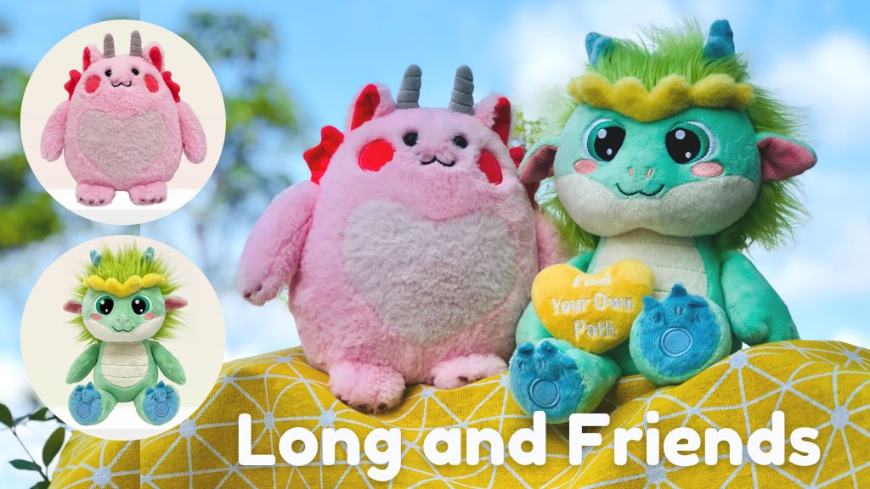
September 26, 2022. San Diego, CA “Long and Friends” are new plushie toys with a unique message of kindness, compassion, and cultural inclusion. Helen H. Wu, a children’s author and publisher seeks to raise funds to bring these cuddly dragon plushies to life, with each tier featuring exciting rewards and additional perks.
"Long means 'Dragon' in Chinese and with our ‘Long and Friends’ dragon plushies, we aim to bridge the cultural differences, bringing children together to revel in the joy of our cuddly companions,” Helen H. Wu, the publisher of Yeehoo Press and the creator of “Long and Friends” says. Each adorable dragon plushie is made of premium soft fabric with colorful embroidered details and comes with a certificate of adoption to make the plushies even more special for children.
In addition to the plushie toys, Long Goes to Dragon School, a picture book written by Helen H. Wu and illustrated by Mae Besom, a New York Times bestselling illustrator, is also available for pre-order. Inspired by the author's experience as a minority immigrant student, this picture book follows a Chinese dragon who struggles to breathe fire in his new Western dragon school, only to discover he must carve his own path to finding a sense of belonging. The book features creative dragon stories to fuel children's imagination, with a “Find Your Own Path” poster in the back of the cover jacket.
"As a new mother fascinated by cultural differences and similarities, I love to share stories that empower children to understand our world," Wu says. “As a publisher, I’m also working to find a creative path in children’s book publishing, creating a dynamic and multi-dimensional learning experience for readers around picture books.” Wu is the publisher of Yeehoo Press, an independent children’s book publisher based in San Diego, California. Yeehoo books are published in English in the US and in Chinese in mainland China.
By contributing to Wu’s Kickstarter campaign, backers will become part of the Dragon School’s mission and bring cuddly companions with a love for cultural differences to children everywhere!
Visit the Kickstarter campaign for Long and Friends at https://www.kickstarter.com/projects/yeehoo/long-and-friends-cute-dragon-plushies-and-enamel-pins
CONTACT: To learn more about Helen H. Wu, the Long and Friends Kickstarter Campaign, or to arrange an interview for an article, please contact Helen at helen@yeehoopress.com
Yeehoo Press: https://yeehoopress.com
Helen H. Wu https://helenhwu.com/
Kickstarter Campaign: https://www.kickstarter.com/projects/yeehoo/long-and-friends-cute-dragon-plushies-and-enamel-pins
Social Media:
https://instagram.com/yeehoopress
https://instagram.com/helenhwu
https://twitter.com/yeehoopress
https://twitter.com/helenhwu
https://www.facebook.com/yeehoopress
https://www.facebook.com/helenhuitingwu
###

